**Homework # 10**

**01286121 Computer Programming**

**Software Engineering Program,**

**Department of Computer Engineering,**

**School of Engineering, KMITL**

By

65011693 Soe Moe Htet

(Nickname – Stephen)

No1

Result:

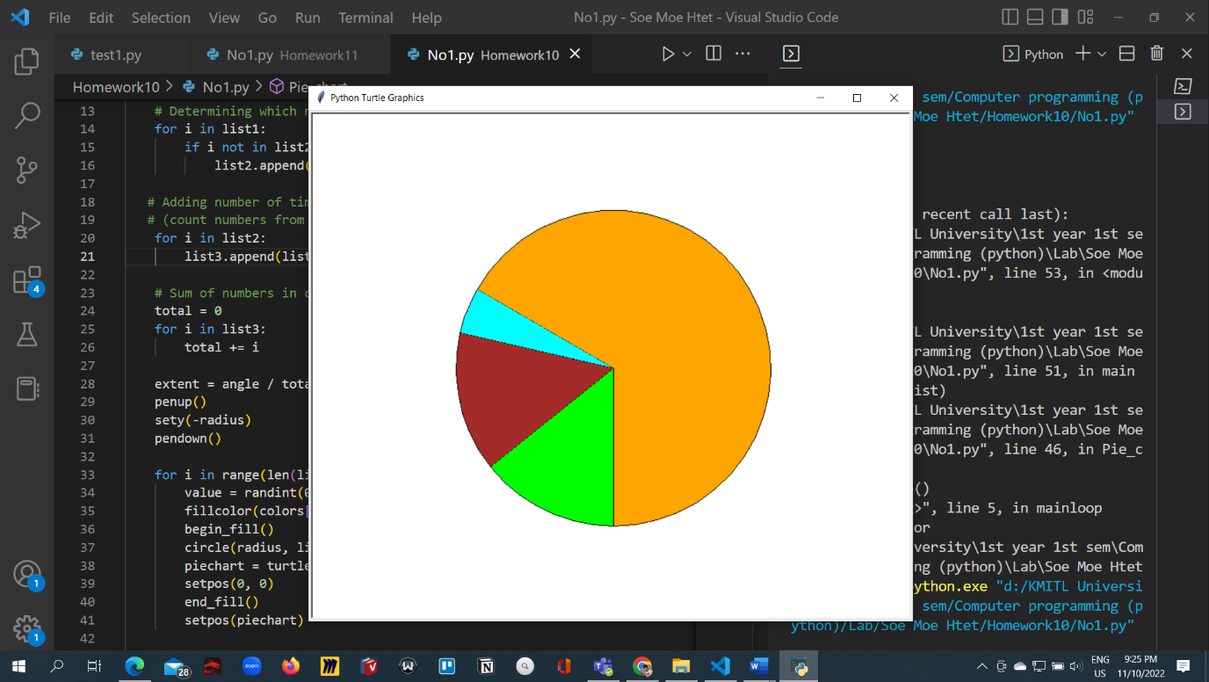

Code:

from random import randint

from turtle import *

import turtle

radius = 200

angle = 360

def Pie_chart(list1):

    list2 = []  # duplicate number list

    list3 = []  # count list

    colors = ["red", "blue", "cyan", "brown", "orange", "green", "purple", "lime"]

    # Determining which numbers are duplicating

    for i in list1:

        if i not in list2:

            list2.append(i)

   # Adding number of times into list3

   # (count numbers from list 2 in list1)

    for i in list2:

        list3.append(list1.count(i))

    # Sum of numbers in count list

    total = 0

    for i in list3:

        total += i

    extent = angle / total

    penup()

    sety(-radius)

    pendown()

    for i in range(len(list3)):

        value = randint(0, len(colors)- 1)

        fillcolor(colors[value])

        begin_fill()

        circle(radius, list3[i] * extent)

        piechart = turtle.position()

        setpos(0, 0)

        end_fill()

        setpos(piechart)

    turtle.hideturtle()

    turtle.mainloop()

    turtle.done()

def main():

    list = [3, 1, 3, 3, 2, 3, 3, 2, 3, 2, 4, 3, 3, 3, 3, 4, 3, 3, 3, 4, 3]

    Pie_chart(list)

main()

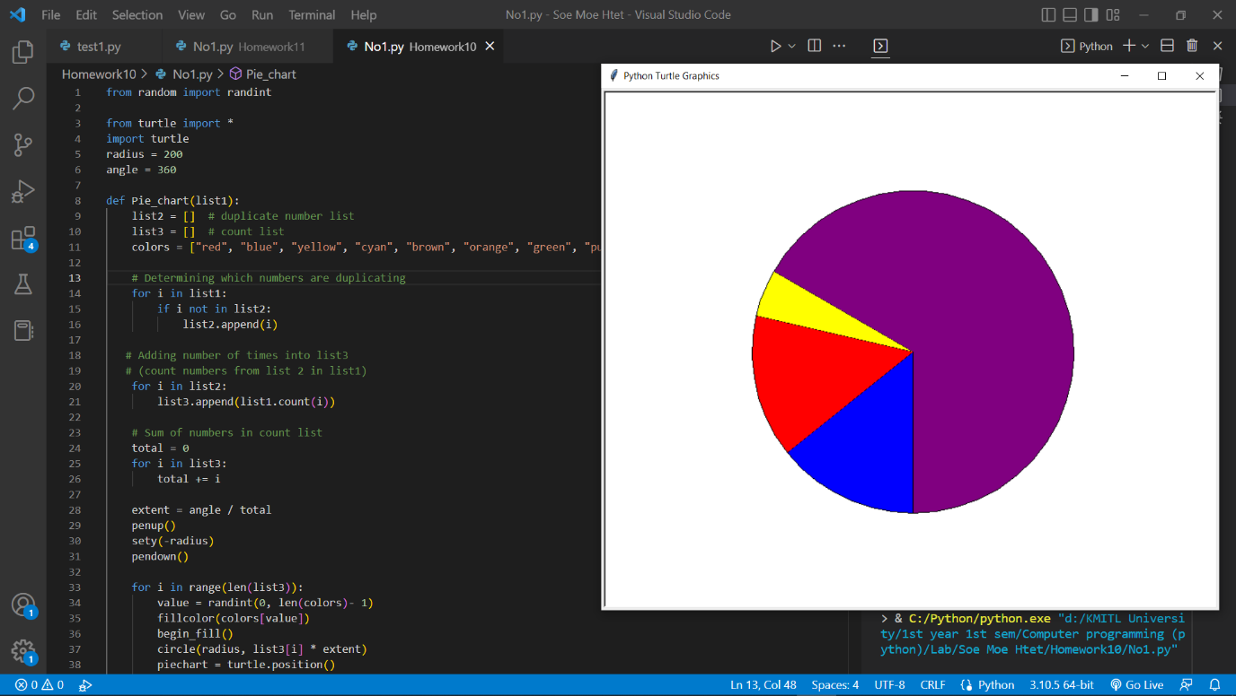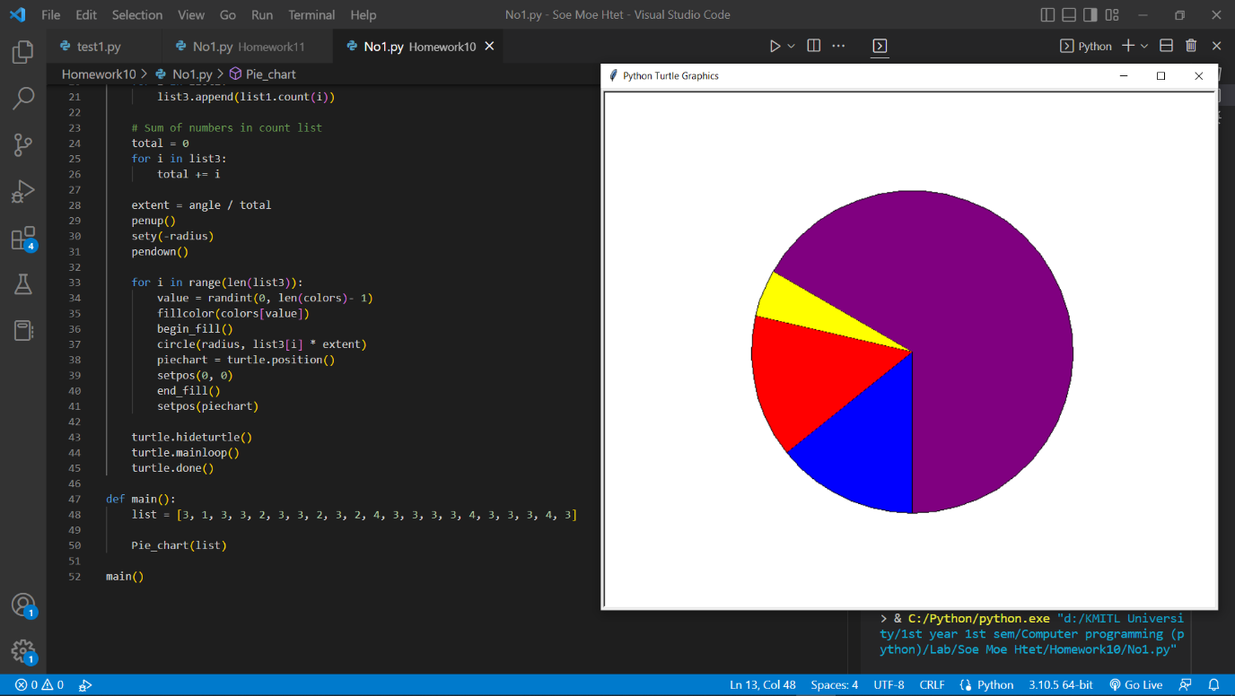

No.2

Code:

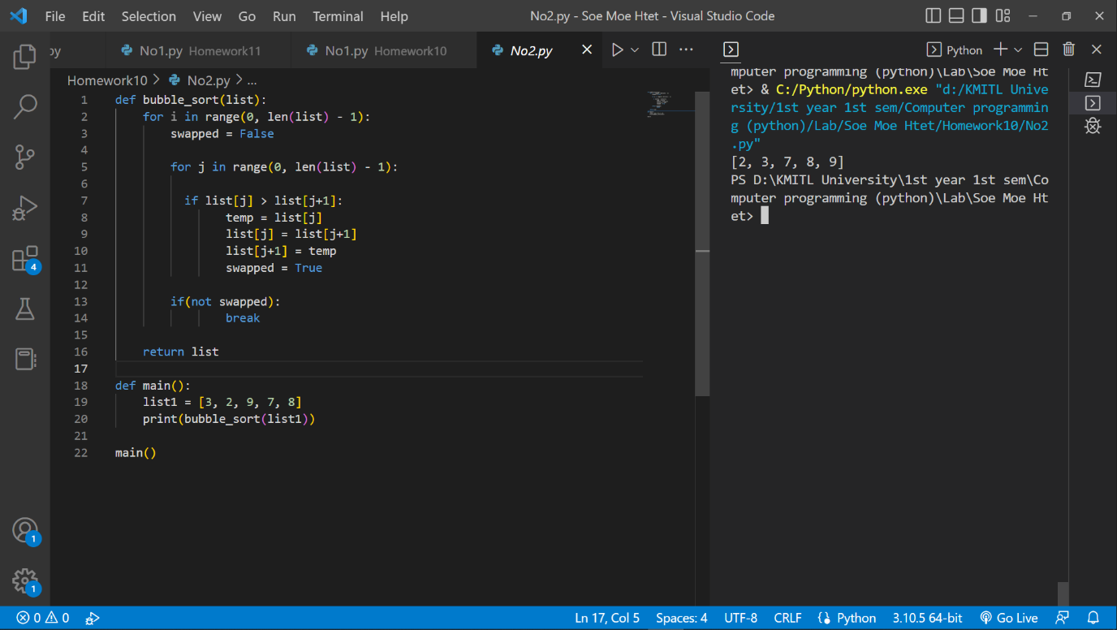

def bubble_sort(list):

    for i in range(0, len(list) - 1):

        swapped = False

        for j in range(0, len(list) - 1):

          if list[j] > list[j+1]:

                temp = list[j]

                list[j] = list[j+1]

                list[j+1] = temp

                swapped = True

        if(not swapped):

                break

    return list

def main():

    list1 = [3, 2, 9, 7, 8]

    print(bubble_sort(list1))

main()

No.3

Result:

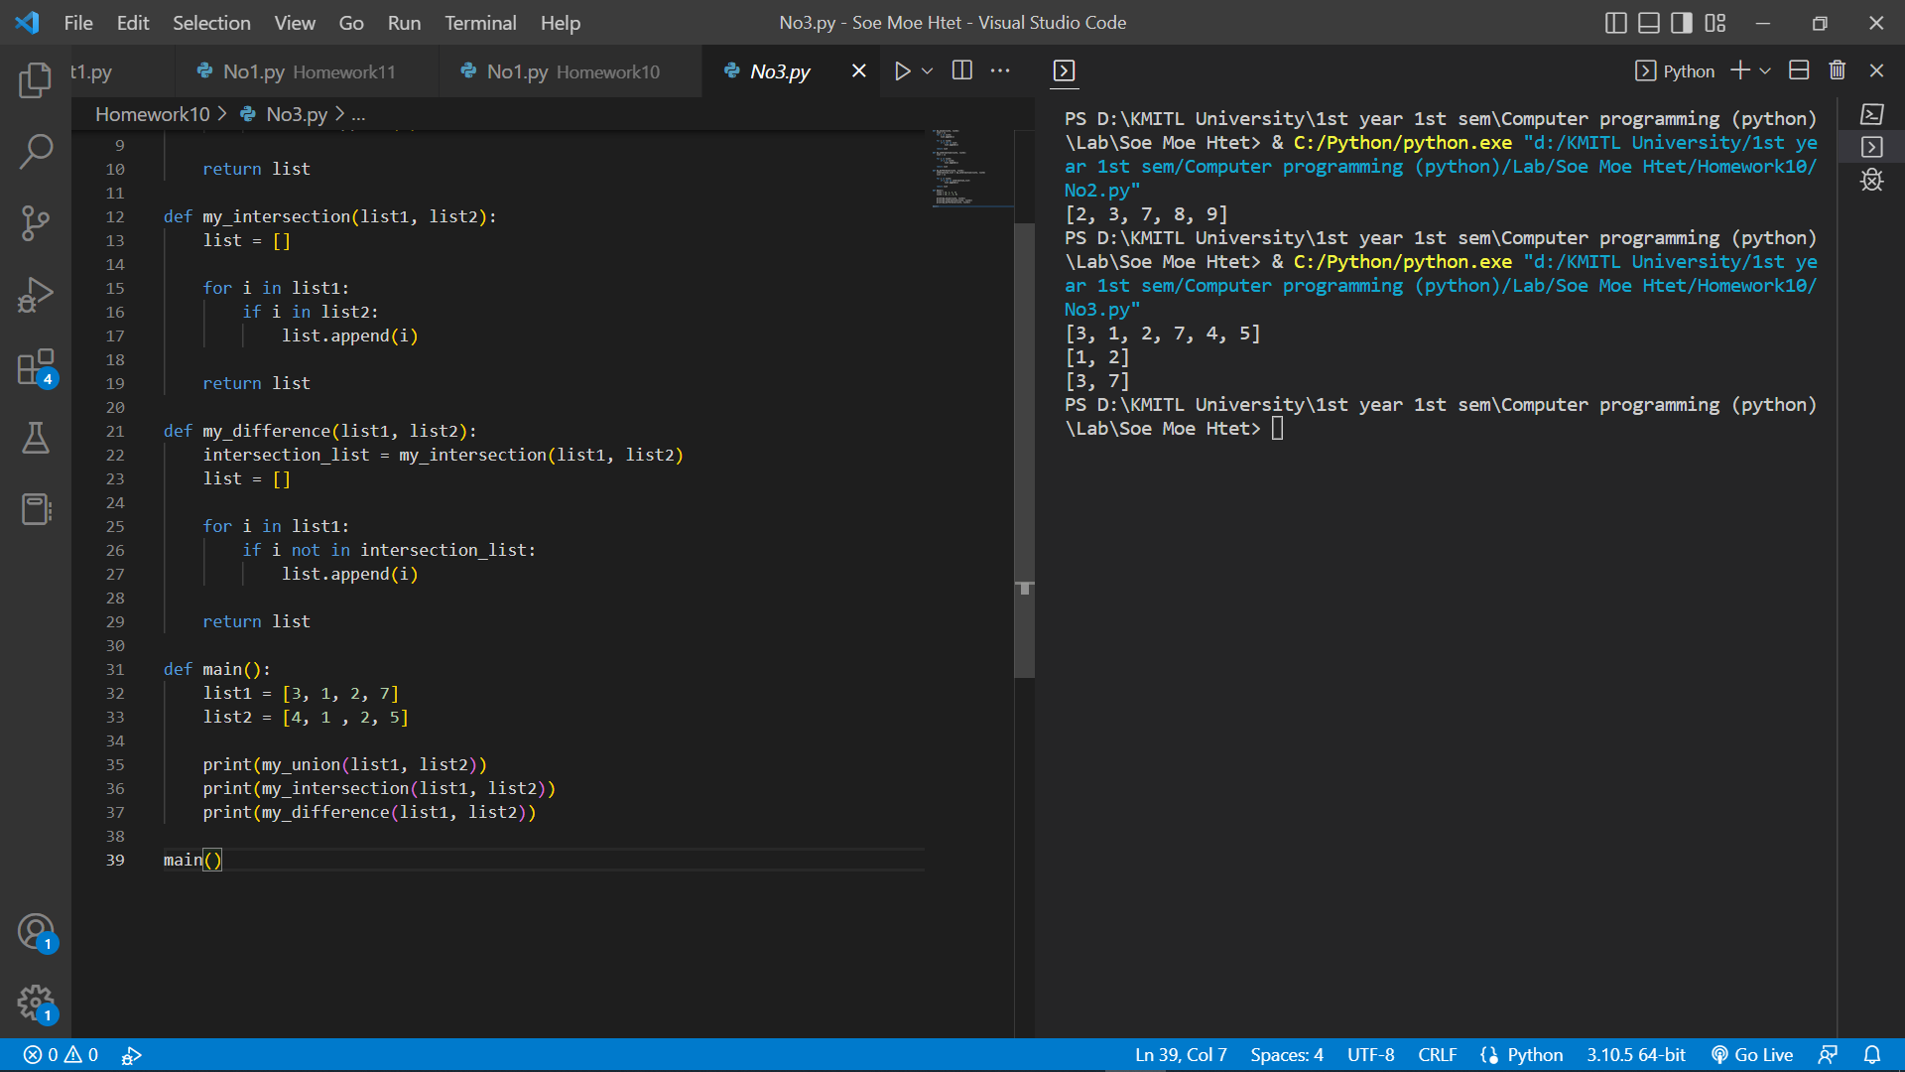

Code:

def my_union(list1, list2):

    list = []

    for i in list1:

        list.append(i)

    for i in list2:

        if i not in list:

            list.append(i)

    return list

def my_intersection(list1, list2):

    list = []

    for i in list1:

        if i in list2:

            list.append(i)

    return list

def my_difference(list1, list2):

    intersection_list = my_intersection(list1, list2)

    list = []

    for i in list1:

        if i not in intersection_list:

            list.append(i)

    return list

def main():

    list1 = [3, 1, 2, 7]

    list2 = [4, 1 , 2, 5]

    print(my_union(list1, list2))

    print(my_intersection(list1, list2))

    print(my_difference(list1, list2))

main()

No.4

Result

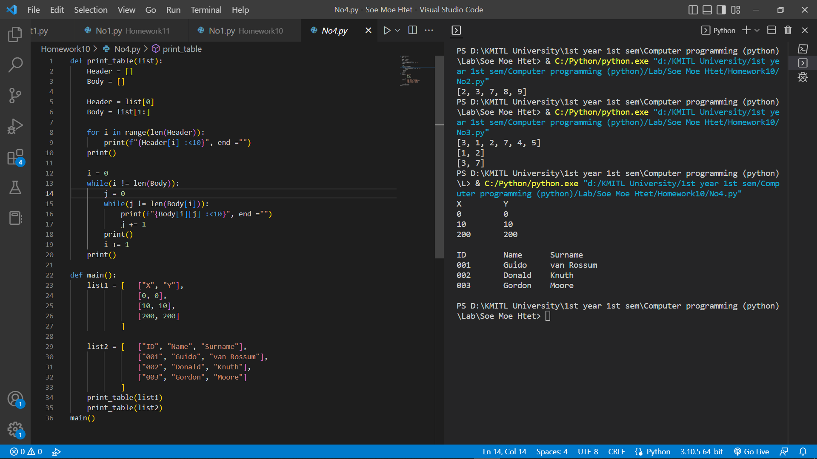

Code:

def print_table(list):

    Header = []

    Body = []

    Header = list[0]

    Body = list[1:]

    for i in range(len(Header)):

        print(f"{Header[i] :<10}", end ="")

    print()

    i = 0

    while(i != len(Body)):

        j = 0

        while(j != len(Body[i])):

            print(f"{Body[i][j] :<10}", end ="")

            j += 1

        print()

        i += 1

    print()

def main():

    list1 = [   ["X", "Y"],

                [0, 0],

                [10, 10],

                [200, 200]

            ]

    list2 = [   ["ID", "Name", "Surname"],

                ["001", "Guido", "van Rossum"],

                ["002", "Donald", "Knuth"],

                ["003", "Gordon", "Moore"]

            ]

    print_table(list1)

    print_table(list2)

main()

No.5

Result:

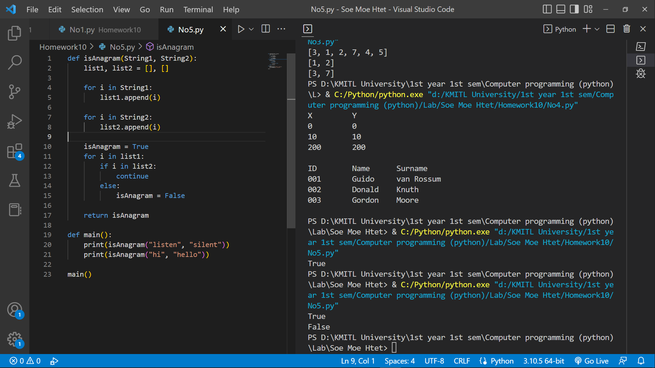

Code:

def isAnagram(String1, String2):

    list1, list2 = [], []

    for i in String1:

        list1.append(i)

    for i in String2:

        list2.append(i)

    isAnagram = True

    for i in list1:

        if i in list2:

            continue

        else:

            isAnagram = False

    return isAnagram

def main():

    print(isAnagram("listen", "silent"))

    print(isAnagram("hi", "hello"))

main()